**3 SUCCESS STORY OF DIGITAL TRANSFORMATION COMPANIES**

1. **NIKE**

Nike, Inc. is an American multinational association that is involved in the design, development, manufacturing and worldwide marketing and sales of apparel, footwear, accessories, equipment and services.

The company’s world headquarters are situated near Beaverton, Oregon, in the Portland metropolitan area (USA). It is a major producer of sports equipment and one of the world’s largest suppliers of athletic shoes and apparel.

It employs more than 44,000 people worldwide and in 2014 the brand alone was valued as $19 billion (€17,5 billion), making it the most valuable brand between sports businesses. Founded by Bill Bowerman and Phil Knight on January 25, 1964, as Blue Ribbon Sports, the company became officially Nike, Inc. on May 30, 1971. The company was named after the Greek goddess of victory, Nike (Νίκη).

Apart from its own brand, Nike market its products under Nike Pro, Nike+, Nike Golf, Nike Blazers, Air Jordan, Air Max and other as well as subsidiaries including brands Jordan, Hurley Int. and Converse.

Nike sponsors many high-profile athletes and sports teams around the world, with the highly recognized trademarks of “Just Do It” and the Swoosh logo (which represents the wing of the Greek goddess Nike)

* **Technology Used**
* Big Data Analytics
* Artificial Intelligence (AI)
* Internet of Things (IoT)
* Cloud Computing
* Mobile Applications
* **Before and After Story**
* **Before:** Nike's primary focus was on manufacturing and selling sportswear and equipment through traditional retail channels. They faced stiff competition and had limited direct interaction with customers.
* **After:** Nike embraced digital transformation to become a direct-to-consumer (DTC) brand. They leveraged data analytics, AI, and mobile technology to enhance customer experience and streamline operations.
* **Strategies Used**
* Launched the Nike+ app to connect with customers directly, providing personalized product recommendations and fitness tracking.
* Utilized big data to analyse customer preferences and tailor marketing campaigns.
* Implemented IoT in products like the Nike Adapt shoes, which use smartphone apps to customize fit and performance.
* Shifted to a cloud-based infrastructure to improve operational efficiency and scalability.
* **Challenges Faced**
* Transitioning from a traditional retail model to a DTC model required significant investment and restructuring.
* Ensuring data privacy and security for customer information.
* Integrating new technologies with existing systems and processes.
* **Why Businesses are Moving Towards Digital Transformation**
* Improving customer engagement and experience by providing personalized services.
* Achieving a competitive edge through utilizing data analysis for enhanced decision-making.
* Enhancing operational efficiency and cutting costs by utilizing automation and cloud services.

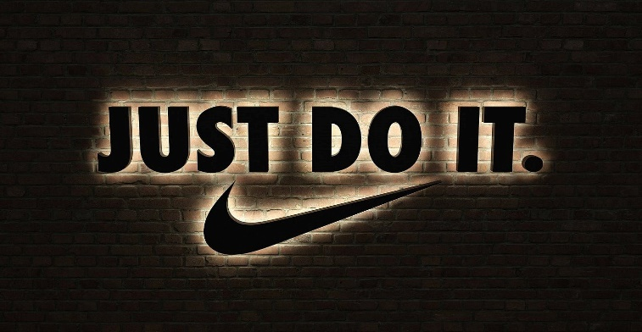

1. **STARBUCKS**



Starbucks is an American company that operates the largest [coffeehouse](https://www.britannica.com/topic/cafe-eating-and-drinking-establishment) chain and one of the most recognizable [brands](https://www.britannica.com/money/brand) in the world. Headquartered in [Seattle](https://www.britannica.com/place/Seattle-Washington), Washington, the company operates more than 35,000 stores across 80 countries (as of 2022).

The original Starbucks logo in a window of the company's store at Pike Place Market in Seattle.

Although Starbucks was not the first major coffeehouse chain in the U.S., it was the first to both popularize and mass-distribute a particular brand of café culture. Starting in the 1990s, Starbucks began promoting coffee as a holistic experience that combined ambiance, community, function, and lifestyle. By transforming people’s perception of coffee and coffeehouses, Starbucks achieved outsize growth and established itself as one of the most dominant names in the coffeehouse industry.

* **Technology Used**
* Mobile Payment Systems
* Artificial Intelligence (AI)
* Big Data Analytics
* Cloud Computing
* Internet of Things (IoT)
* **Before and After Story**
* **Before:** Starbucks operated primarily through its physical stores, relying on traditional marketing and customer service methods.
* **After:** The company adopted digital transformation to provide a seamless and personalized customer experience. They integrated mobile technology, AI, and data analytics into their operations.
* **Strategies Used**
* Introduced the Starbucks mobile app for order and payment, loyalty programs, and personalized offers.
* Leveraged AI and big data to customize marketing efforts and product recommendations.
* Implemented IoT-enabled coffee machines to ensure consistent quality and efficiency in service.
* Utilized cloud computing to manage data and support scalability.
* **Challenges Faced**
* Integrating digital systems with physical store operations.
* Managing the vast amount of data generated by digital platforms.
* Ensuring a consistent customer experience across all touchpoints.
* **Why Businesses are Moving Towards Digital Transformation**
* To meet evolving customer expectations for convenience and personalization.
* To streamline operations and reduce costs through automation.
* 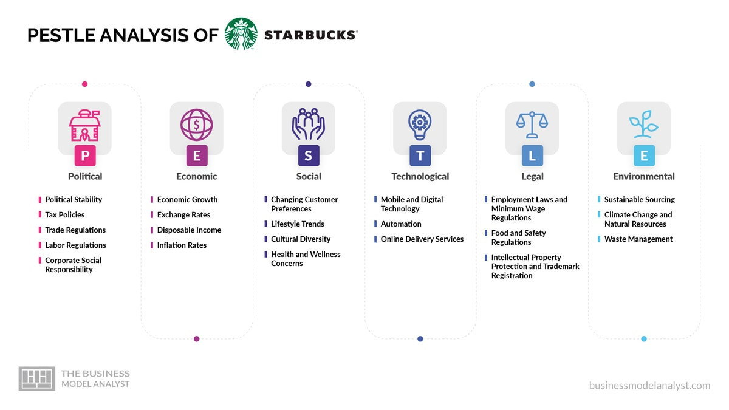To harness data for strategic insights and improved decision-making.

1. **DOMINO'S PIZZA**

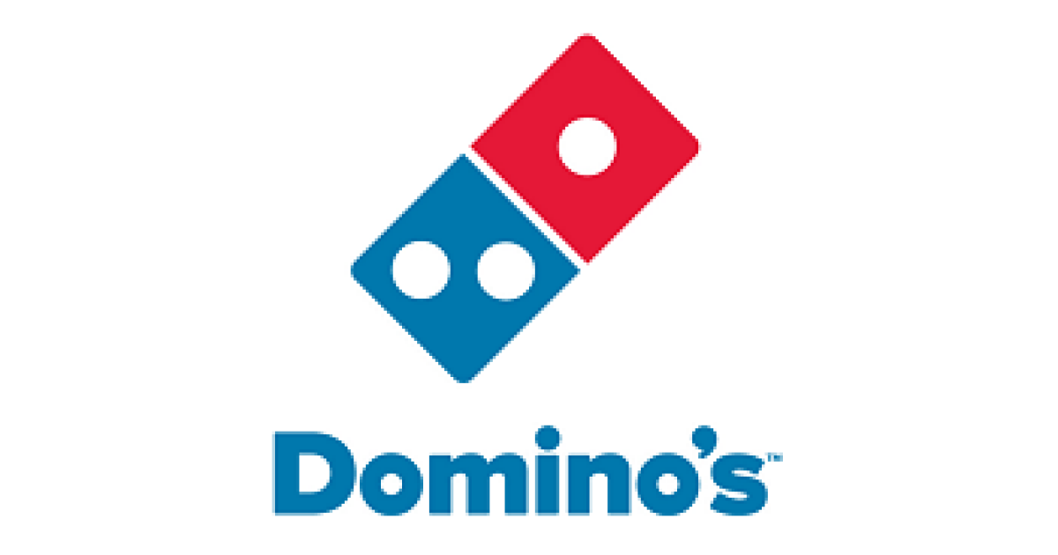

Jubilant Food Works Limited (the Company) is a Jubilant Bhartia Group Company. The Company was incorporated in 1995 and initiated operations in 1996. The Company got listed on the Indian bourses in February 2010. Mr. Shyam S. Bhartia, Mr. Hari S. Bhartia and Jubilant Consumer Pvt. Ltd. (formerly Jubilant Fresh Pvt. Ltd.) are the Promoters of the Company. The Company & its subsidiary operates Domino's Pizza brand with the exclusive rights for India, Nepal, Bangladesh and Sri Lanka. The Company is market leader in the pizza segment with a network of 1,249 Domino’s Pizza restaurants across 276 cities in India (as on June 30, 2019).

The Company is the market leader in the organized pizza market in the pizza home delivery segment in India, The Company has strengthened its portfolio by entering into an agreement with Dunkin' Donuts Franchising LLC, for developing the Dunkin' Donuts brand and operating restaurants in India,

Over the period since 1996, Domino's Pizza India has remained focused on delivering great tasting Pizzas and sides, superior quality, exceptional guest care and value for money offerings. We have endeavoured to establish a reputation for being a home delivery specialist capable of delivering pizzas within 30 minutes or else FREE to a community of loyal consumers from all our restaurants around the country.

Domino's vision is focused on " Exceptional people on a mission to be the best pizza delivery company in the world!" We are committed to bringing fun, happiness and convenience to lives of our consumers by delivering delicious pizzas to their doorstep and our efforts are aimed at fulfilling this commitment towards a large and ever-growing guest base.

Domino's constantly strives to develop products that suit the tastes of our consumers and hence delighting them. Domino's believes strongly in the strategy of 'Think global and act local'. Thus, time and again we have been innovating with delicious new products such as crusts, toppings and flavours suitable to the taste buds of Indian Consumers. Further providing value for money and affordable products to our consumers has been an important part of our efforts. Our initiatives such as Fun Meal and Pizza Mania have been extremely popular with consumers looking for an affordable and value for money meal option.

Domino's believes that when a box of pizza is opened, family and friends come together to share the pizza. Hence, our brand positioning: ‘Yeh Hai Rishton Ka Time'

That's why, all our efforts, whether it is a new innovative and delicious product, offering consumers value for money deals, great service, countrywide presence or the promise to deliver in 30 minutes or free are all directed towards making relationships stronger, warmer and more fun by giving consumers an opportunity to get together, catch up, reunite and spend more time together.

* **Technology Used**
* Mobile Applications
* Artificial Intelligence (AI)
* Internet of Things (IoT)
* Voice Recognition Technology
* Data Analytics
* **Before and After Story**
* Before: Domino's relied heavily on traditional methods for ordering, such as phone calls and in-store visits. Their delivery system and customer interaction were less efficient and less personalized.
* After: Domino's embraced digital technology to revolutionize their ordering and delivery process, resulting in a significant increase in sales and customer satisfaction.
* **Strategies Used**
* Developed a user-friendly mobile app and website for easy ordering and tracking.
* Integrated AI and voice recognition for ordering via virtual assistants like Amazon's Alexa and Google Assistant.
* Used IoT to optimize delivery routes and ensure timely deliveries.
* Leveraged data analytics to understand customer preferences and personalize marketing campaigns.
* **Challenges Faced**
* Transitioning to a primarily digital ordering system.
* Ensuring the security of customer data.
* Maintaining consistency in service quality across different platforms.
* **Why Businesses are Moving Towards Digital Transformation**
* To provide a seamless and convenient customer experience.
* To streamline operations and improve delivery efficiency.
* To utilize data for better customer insights and targeted marketing.

